Major Project Proposal on

**Doctor Appointment and Recommendation System (Web Application)**

Submitted in partial fulfillment of the requirements for the degree of

**Bachelors of Engineering in Information Technology**

under Pokhara University

Submitted by:

**Ankit Budhathoki, 15454**

**Ashbin Thapa, 15455**

Date:

23rd FEB 2023

**Department of Information Engineering**

**NEPAL COLLEGE OF**

**INFORMATION TECHNOLOGY**

Balkumari, Lalitpur, Nepal   
**ABSTRACT**

*Doctor Appointment and Recommendation System is a web application, which automates the manual system by the help of computerized system that enables patients to schedule appointments with medical professionals. It also helps healthcare provider to manage the information and data for a longer period in a secure and systematic way.*

*Doctor Appointment and Recommendation System can help to lead an error free, secure, reliable and fast management system. It can assist the user to concentrate on their other activities rather than concentrating on finding doctor. The aim is to automate its existing manual system by the help of computerized equipment and fully functional computer software, fulfilling their requirements, so that their valuable data can be stored for a longer period with easy accessing. The project describes how to manage for good performance and better services for the clients.*

*The system typically includes a user-friendly interface that allows patients to search for available doctors, choose an appointment time, which suits them. Healthcare professionals can use the system to manage their schedule, access patient information. The use of a doctor appointment system can streamline medical practice and increase patient satisfaction by making it more systematic. The system employs various algorithms and techniques, such as collaborative filtering, content-based filtering, and machine learning, to provide personalized recommendations to patients. The aim of a doctor appointment and recommendation system is to improve patient outcomes by ensuring that patients receive appropriate and high-quality healthcare services. This abstract provides an overview of a doctor appointment and recommendation system and its potential benefits for both patients and healthcare providers.*

Keywords: Computerized System, Appointment, Coding, Software Programming, Recommendation

Contents

**1.** **INTRODUCTION** 1

1.1. PROBLEM STATEMENT 1

1.2. OBJECTIVES 2

1.3. PROJECT SCOPE AND LIMITATIONS 2

1.3.1. SCOPE 2

1.3.2. LIMITATIONS 2

1.4. SIGNIFICANCE OF STUDY 3

2.1. PREVIOUS SIMILAR WORKS 4

**3.** **METHODOLOGY** 7

3.1. SOFTWARE DEVELOPMENT LIFE CYCLE 7

3.1.1. REQUIREMENT PHASE 8

3.1.2. ANALYSIS AND DESIGN PHASE 8

3.1.3. IMPLEMENTATION 8

3.1.4. TESTING 8

3.1.5. EVALUATION 8

3.2. WHY ITERATIVE MODEL? 8

3.3. TOOLS USED 9

3.4. TECHNOLOGIES 9

**4.** **PROJECT PERFORMANCE ANALYSIS METHODOLOGY** 10

**5.** **PROPOSE DELIVERABLES** 12

**6.** **PROJECT TASK AND TIME SCHEDULE** 13

6.1. GANTT CHART 14

**7.** **REFERENCE** 15

**LIST OF TABLES**

Table 1: Tools used 10

Table 2: Project Task and Time Schedule 14

**LIST OF FIGURES**

Figure 1: Iterative model of software development life cycle 8

Figure 2: Gantt Chart 15

# 

# **INTRODUCTION**

The Doctor Appointment and recommendation System is developed to override the problems prevailing in the practicing manual system. This software is supported to eliminate and, in some cases, reduce the hardships faced by this existing system. Moreover, this system is designed for the particular need of the company to carry out operations in a smooth and effective manner.

The application is reduced as much as possible to avoid errors while entering the data. It also provides error message while entering invalid data. No formal knowledge is needed for the user to use this system. Thus, by this all it proves it is user-friendly. Doctor Appointment and Recommendation System, as described above can lead to error free, secure, reliable and fast management system. It can assist the user to concentrate on their other activities rather to concentrate on their other activities rather to concentrate on finding doctor. Thus, it will help organization in better utilization of resources.

Every organization, whether big or small, has challenges to overcome and managing the information of appointment, doctor, booking and doctor schedule

## PROBLEM STATEMENT

The problem that a doctor appointment and recommendation system aim to solve is the inefficient and time-consuming process of scheduling medical appointments.

Traditionally, patients have had to call or visit a medical office to make an appointment, which can be inconvenient and time consuming. Patients also experience long waiting times and have difficulty getting in touch with medical professionals. At the same time, medical professionals face the challenge of managing their busy schedules, tracking patient appointments, and accessing patient information in a timely and accurate manner. The result is a system that can be frustrating for both patients and medical professionals and can lead to decreased patient satisfaction and healthcare outcomes.

A doctor appointment and recommendation system seek to address these issues by providing an efficient and user-friendly platform for scheduling appointments, accessing medical information, and communicating with healthcare providers, ultimately improving the patient experience and enabling better healthcare outcomes.

## OBJECTIVES

The drawbacks mentioned in problem statement needs to be solved, for which a new and easier method for taking appointment is needed to be derived. The main objective of a doctor appointment and recommendation system is to improve patient outcomes by providing personalized recommendations for healthcare providers. Doctor Appointment and Recommendation System is a web application where the patient can book their appointments with their preferred doctors. Similarly, this web application recommends the best doctors for the treatment of the patients as well. Following are the objectives of this project:

1. Enhancing patient satisfaction by providing recommendations of doctors,
2. Provides the searching facilities based on various factors such as Doctor, Patient, Booking, Doctor Schedule,
3. Tracks all the information of Appointment and Booking,
4. To increase efficiency of managing the Doctor and Patient,
5. Integration of all records of Doctor Schedule.

## PROJECT SCOPE AND LIMITATIONS

The scope of this project is to provide patient with all the services through a web-based networking service. In this project, a web application will be developed where patient will be able to make an appointment with their desired doctors.

### SCOPE

1. The targeted people are patients.
2. This app can be modified and used for various health sectors.

### LIMITATIONS

1. This is only website not a app.
2. This app is mainly focus to patients.

## SIGNIFICANCE OF STUDY

This project is proposed with the intention to develop a Web Application of the appointment platform where patient can book an appointment for their check-up and get the best doctors. The existing platform provides the appointment platform however; this project will have some additional features regarding the appointments of doctor and recommendation feature. So, this project is meant for providing user-friendly web application in efficient way.

1. **LITERATURE REVIEW**

## PREVIOUS SIMILAR WORKS

**Zocdoc** is an online platform that connects patients with healthcare providers and enables them to book appointments online. It was founded in 2007 and has since become one of the most popular healthcare appointments booking platforms in the US.

Pros:

Convenience: Zocdoc makes it easy for patients to find and book appointments with healthcare providers, without having to call different clinics or hospitals. Patients can view real-time availability of healthcare providers and schedule appointments at their convenience.

Personalized recommendations: Zocdoc provides personalized recommendations for healthcare providers based on patients' location, insurance, and medical needs, making it easier for patients to find the right healthcare provider.

Reviews and ratings: Zocdoc allow patients to leave reviews and ratings for healthcare providers, which can help other patients make informed decisions about which healthcare provider to choose.

Integration with EHR: Zocdoc can be integrated with electronic health records (EHR) systems, which can save time for healthcare providers by eliminating the need for manual data entry.

Cons:

Limited availability: Zocdoc is only available in certain regions of the US, which means that not all patients and healthcare providers can use the platform.

Cost: Zocdoc charges healthcare providers a fee for each booking made through the platform, which can be expensive for smaller clinics and hospitals.

Data privacy: Zocdoc has faced criticism in the past for its data privacy policies, as some patients have reported that their personal information was shared with third-party companies without their consent.

Limited appointment types: Zocdoc is primarily designed for booking appointments with primary care physicians and specialists, and may not be suitable for booking appointments for certain types of medical procedures or tests.

**Healthgrades** is an online platform that allows patients to search for and review healthcare providers based on their specialty, location, and patient reviews. Patients can also book appointments with healthcare providers through the platform.

Pros:

Patient reviews: Healthgrades allows patients to leave reviews and ratings for healthcare providers, which can help other patients make informed decisions about which healthcare provider to choose.

Physician profiles: Healthgrades provides detailed profiles of healthcare providers, including their education, certifications, and specialties, which can help patients choose a healthcare provider who meets their needs.

Telemedicine appointments: Healthgrades allows patients to book telemedicine appointments with healthcare providers, which can be especially helpful for patients who live in remote areas or have difficulty traveling to appointments.

Cons:

Limited appointment availability: While patients can book appointments with healthcare providers through Healthgrades, not all healthcare providers may be available through the platform.

Cost: Healthgrades charges healthcare providers a fee for premium services, which may be expensive for smaller clinics and hospitals.

Data privacy: Healthgrades has faced criticism in the past for its data privacy policies, as some patients have reported that their personal information was shared with third-party companies without their consent.

Inaccurate information: Healthgrades may not always have up-to-date information about healthcare providers, which can lead to inaccurate information being displayed on the platform.

# **METHODOLOGY**

In this section we have described about the method that we will be using to meet the requirement of the project.

## SOFTWARE DEVELOPMENT LIFE CYCLE

The model to be used for developing of this project is Iterative model of SDLC. Iterative model is simple and emphasizes on initial and simple implementation and with progress in the project it gains more feature. It is advantageous since it has unique feature of repetitive nature i.e. during development phase one can go back to check out the previous works without any complications and flaws can be improved if any. Further explanation about the model has been described below.

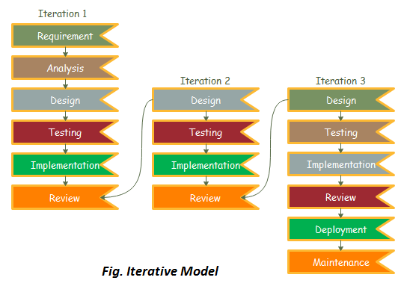

Figure 1: Iterative model of software development life cycle

### REQUIREMENT PHASE

In this phase, all the necessary requirements are analysed. Till now necessary requirement for further analysis of project is gathered from end-user, Internet and teachers. And as a result, final specification of the project will be gained.

### ANALYSIS AND DESIGN PHASE

In this phase, the specification gathered is designed as per the requirement. Further the database models, technical requirement and the logic will be implemented in the project.

### IMPLEMENTATION

After the analysis and design the coding is done according to the specifications. Coding is in progress and hence a working system will be obtained in this phase.

### TESTING

Once a system is developed series of testing will be performed in order to remove bugs and errors. Also, in this phase certain changes, if necessary, will also be applied to obtain complete and successful system.

### EVALUATION

Evaluation is the last step performed after all the prior steps, where the project will be evaluated to check if it meets the specification or not.

## WHY ITERATIVE MODEL?

Requirements can be changed if necessary by going back to the previous phases without any effect to the further ongoing process.

## TOOLS USED

|  |  |
| --- | --- |
| TOOLS | PURPOSE |
| PHP | Whole application base creation platform |
| GitHub | To manage Source Code |
| Adobe Photoshop CS6 | Logo Design |
| Web Browser | For Testing |

Table 1: Tools used

## TECHNOLOGIES

* Operating system: Windows 8/10/11.
* PHP Programming language for Backend.
* HTML, CSS.
* MYSQL, for database.
* Web Browser.

# **PROJECT PERFORMANCE ANALYSIS METHODOLOGY**

Project Performance Analysis Methodology:

Define metrics: The first step in analyzing the performance of a question-answer web application is to define the metrics that will be used to measure its performance. This may include metrics such as response time, uptime, number of users, user engagement, and conversion rates.

Collect data: Once the metrics have been defined, data should be collected on a regular basis to measure the application's performance. This may involve using tools such as Google Analytics, server logs, or custom tracking scripts.

Identify areas for improvement: Based on the analysis, areas for improvement should be identified and prioritized. This may involve addressing performance bottlenecks, improving user experience, or increasing engagement and retention.

Implement changes: Once the areas for improvement have been identified, changes should be implemented to improve the application's performance. This may involve optimizing code, improving server infrastructure, or adding new features to enhance user experience.

Monitor progress: After implementing changes, the application's performance should be monitored to ensure that the changes have had the desired effect. If necessary, additional changes may need to be made to further improve performance.

Validation Scheme:

User testing: One of the most important validation schemes for a web application is user testing. This involves recruiting a group of users to test the application and provide feedback on its usability, functionality, and overall user experience.

Code reviews: Code reviews can help to validate the quality of the application's code and identify potential bugs or issues that may impact performance or user experience.

Functional testing: Functional testing involves testing the application's features and functionality to ensure that they work as intended and meet user needs.

Usability testing: Usability testing involves testing the application's user interface and user experience to ensure that it is easy to use for a wide range of users.

Overall, the validation scheme for a web application should involve a variety of testing and evaluation methods to ensure that it is robust, user-friendly, and performs well under a range of conditions.

# **PROPOSE DELIVERABLES**

The proposed deliverables for a doctor appointment and recommendation system is designed to improve the efficiency and effectiveness of healthcare delivery by providing a user-friendly and secure platform for patients to schedule appointments and provide recommendation of doctors.

The system should have an easy-to-use interface that allows patients to quickly and easily schedule appointments with their preferred healthcare providers. It should also have a module for appointment scheduling that enables patients to choose a date and time that works for them, and receive an automated confirmation of the appointment. The system should be compatible with web browsers, allowing patients to schedule appointments and access medical information. The system should have doctor recommendation system based on patient content. This would provide greater convenience and flexibility for patients, ultimately improving their overall healthcare experience.

Finally, the system should be designed with security measures to protect patient information and ensure compliance with healthcare regulations. Overall, the proposed deliverables for a doctor appointment and recommendation system aim to provide an efficient, secure, and user-friendly platform for patients to access healthcare services, and improve the overall delivery of healthcare services.

# **PROJECT TASK AND TIME SCHEDULE**

The project schedule has been designed as per requirements of the project. Various tasks have been enlisted in the table as per the requirements. Debugging and testing is to be done prior to the completion of the project. Similarly, approximate duration has been scheduled as per the tasks.

|  |  |
| --- | --- |
| **TASK** | **APPROX** **DURATION IN DAYS** |
|  |  |
| Requirements analysis and specification | 25 |
|  |  |
| Under take analysis of the system | 28 |
|  |  |
| Design system | 72 |
|  |  |
| Produce Requirements specification | 39 |
|  |  |
| Testing and debugging | 28 |
|  |  |
| Test system modules | 20 |
|  |  |
| Overall system test | 22 |
|  |  |
| Develop Documents | 56 |
|  |  |

Table 3: Project Task and Time Schedule

## GANTT CHART

The Gantt chart below has been constructed on the basis of the above project schedule. According to the table the project is estimated to be completed in 3 months. The task is started from preliminary investigations and the other tasks are scheduled in accordance.

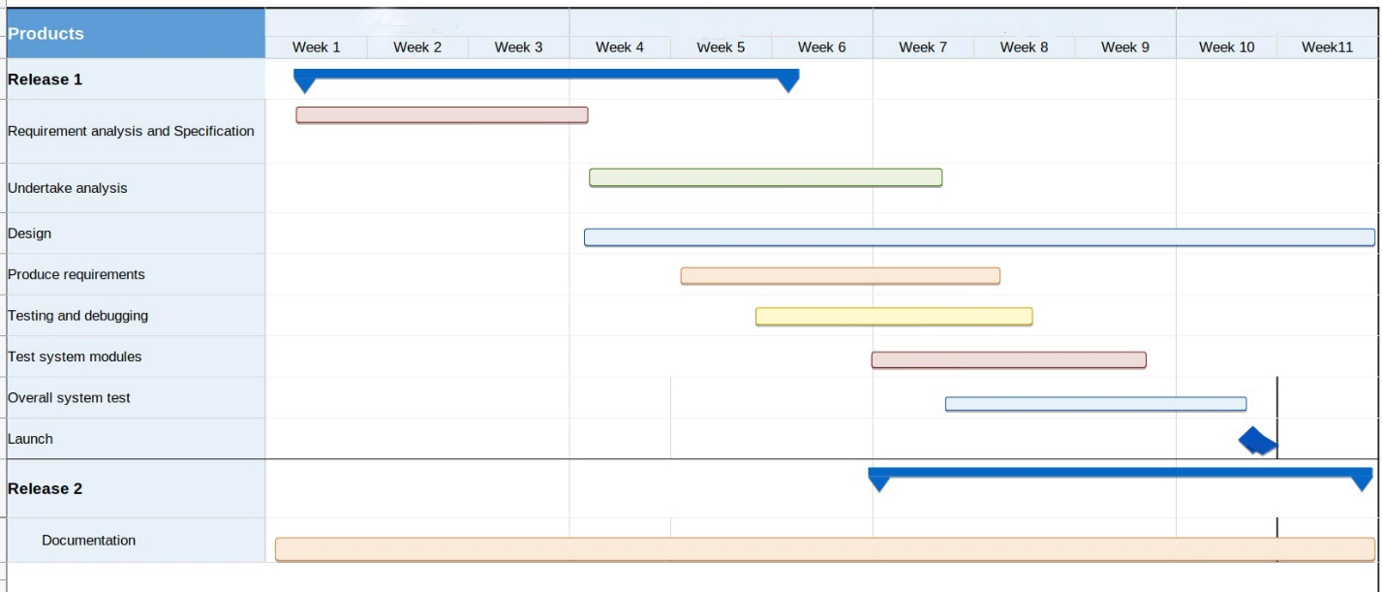

Figure 2: Gantt Chart

# **REFERENCE**

1. Quora. Retrieved from The Pros & Cons of using ZocDocAnswers: https://www.quora.com/What-are-the-pros-and-cons-of-using-ZocDoc-to-make-doctor-appointments
2. Quora. How-much-do-you-value-reviews-ZocDoc-HealthGrades-etc-versus-a-personal-recommendation-when-selecting-a-doctor  
   https://www.quora.com/How-much-do-you-value-reviews-ZocDoc-HealthGrades-etc-versus-a-personal-recommendation-when-selecting-a-doctor
3. 29 May 2021 . Healthgrades application review  
   https://www.apppicker.com/reviews/12416/healthgrades-app-review